COMPOINT Slim Screen Touch Stylus, 2-in-1 Ink Ballpoint Ball Pen, and Slim Stylus for Universal Tablet SmartphoneWith built-In Clip For Easy Carrying
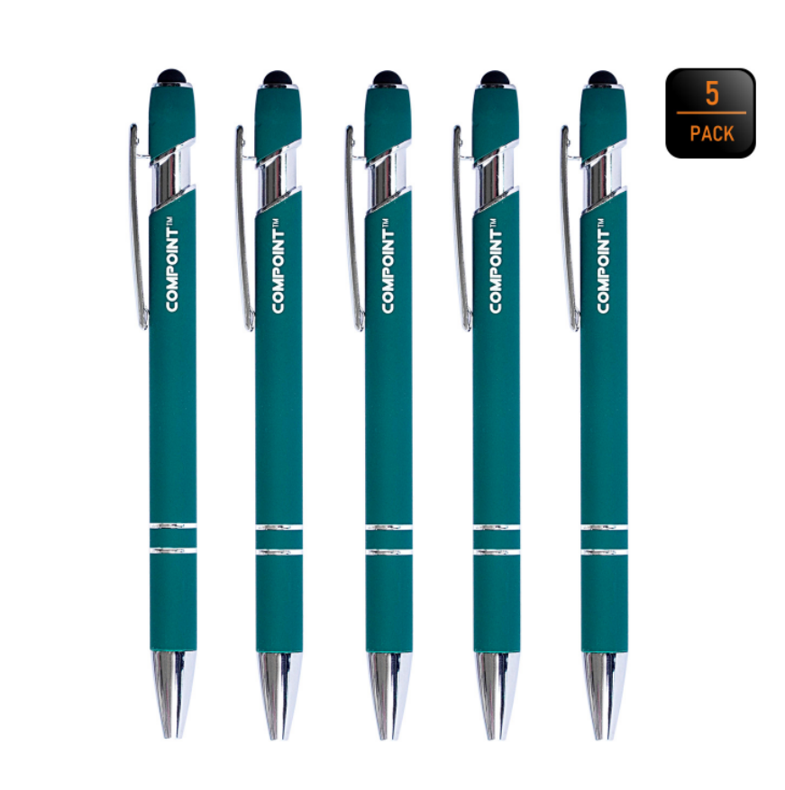

About this item
- 2-IN-1 MULTI-FUNCTION STYLUS ★ slim touch screen stylus serves as both touch screen stylus and ball-point pen
- SENSITIVE STYLUS TIP ★ 100% Compatible with all Capactive touch screen devices. The Soft rubber tipped end with sensitive touching helps reduce scratches and fingerprints on any touch device, works exactly like you finger.
- WIDE COMPATIBILITY ★ Compatible with Samsung Galaxy S8 Plus, S7 Edge, 3DS, 2Ds, Google Nexus 5 7, Samsung Galaxy S6 S6 Edge Tab 4 3 2, Galaxy S III S3 GT-I9300, Galaxy S5 S4, HTC One M8 M7, Blackberry, Other Android Windows Smartphone, Asus Eee Pad Transformer Iconia, Motorola Xoom, Tablet, All Capacitive Touch Screen Device
- ANTI-SCRATCH TIP ★ COMPOINT stylus pen tip was made of soft, and scratch resistant rubber. Fingerprint resistant and anti-stick screen tip, great for drawing writing etc.
- EASY TO CARRY ★ This stylus is very light and compact. The clip design is great for clipping in your pocket, diary, etc. Great stylus for kids.

Product description
Size Name:5-PACK | Colour Name:Black
COMPOINT 2-in-1 slim touch screen stylus serves as both touch screen stylus and ball-point pen.
Sensitive and soft beaded point for any device with touch screen feature. Works as a normal ink ball-point pen
When you use this ballpoint pen, you will regret why you didn't encounter it earlier.
Package Includes:
5 Packs ballpoint pens
Color:
GREEN
BARCODE:
5060808381355
Specification:
- 2-in-1 slim touch screen stylus serves as both touch screen stylus and ball-point pen
- Approx length: 14 cm
- Works as a normal ink ball-point pen
- Compact and lightweight design
- Built-In clip for easy carrying
- Supplied in a protective carrying case

